**Purchase Requisition Summary**

**Date: 04-12-2023**

**Browser: Microsoft Edge**

**In UI:**

1. Rename Product Req to “Purchase Req” for all the field label name
2. Remove Product Req Recommand ID
3. Add Master Group after Product Type
4. Recommend Spelling is wrong

**In PDF:**

1. From Date & To Date is showing wrong
2. Remove Product Type from Column list, add after To Date
3. Add Master Grou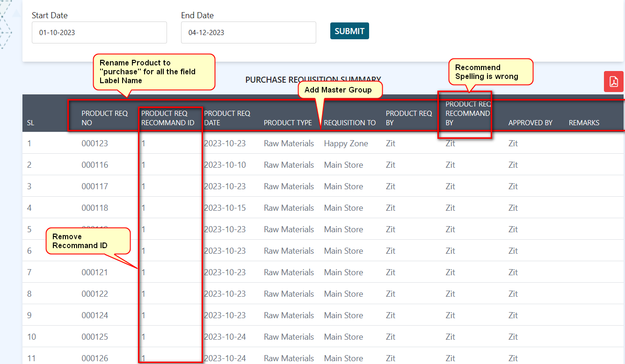p after Product Type
4. 